Docker Task -2
Task Description:
Create a dockerfile, docker-compose file which when executed must display your basic details in the website.
Created the EC2 instance
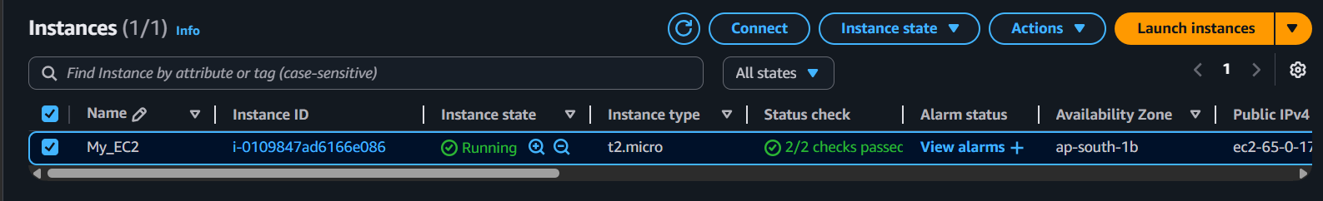
Create the docker file.
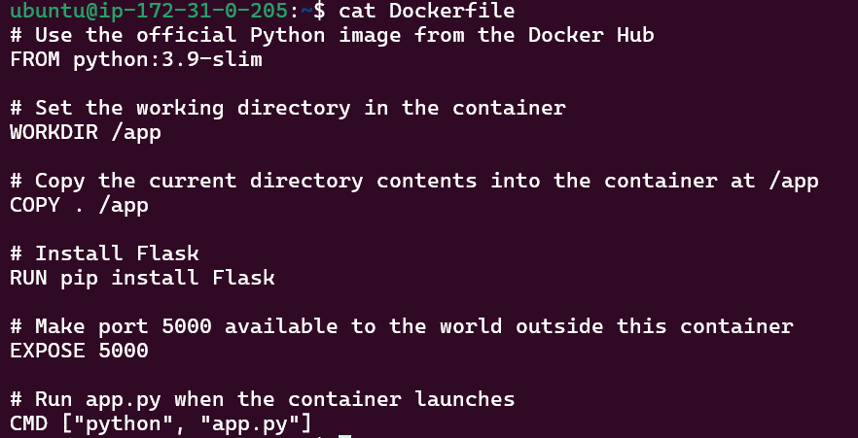
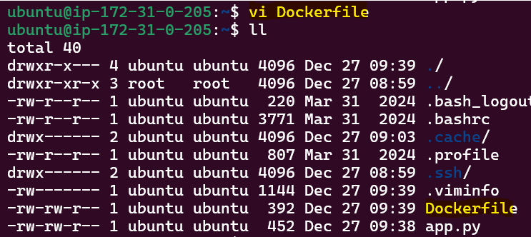
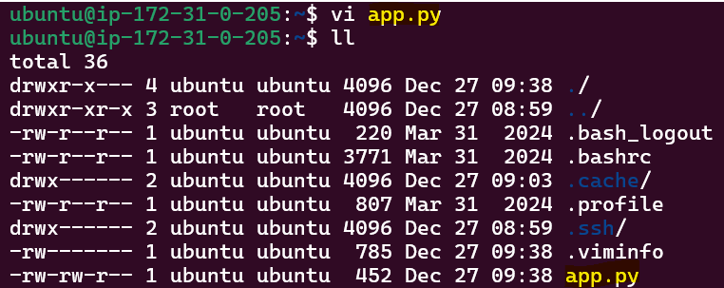
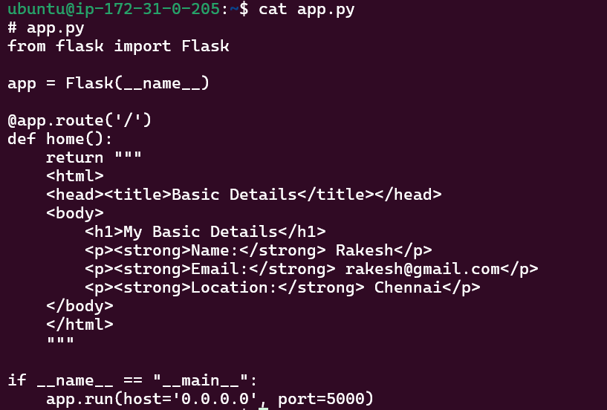

Install docker on the EC2 server 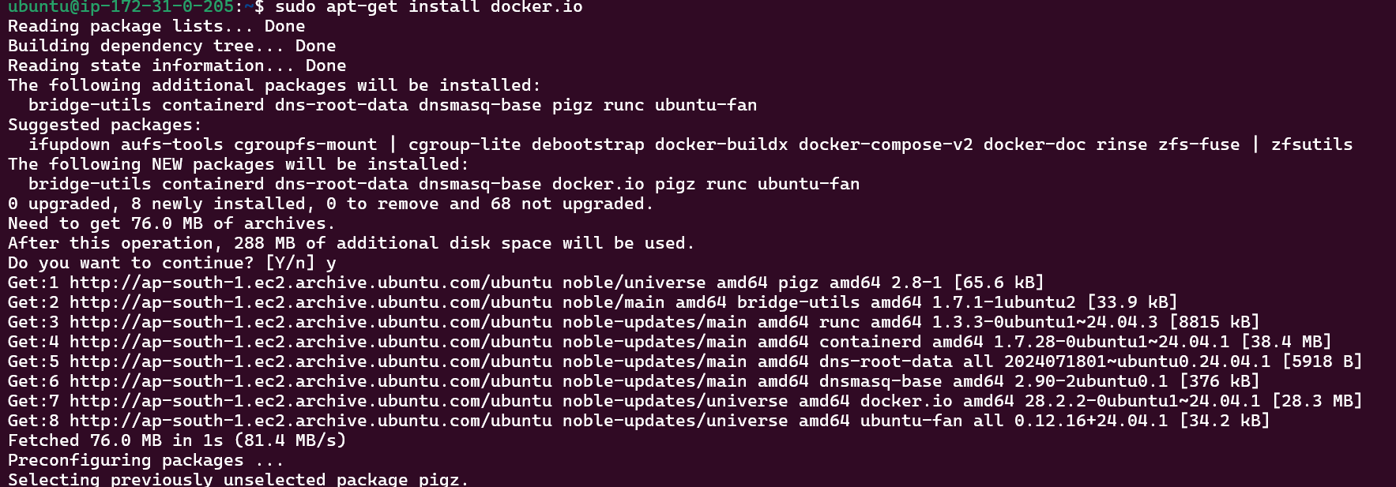
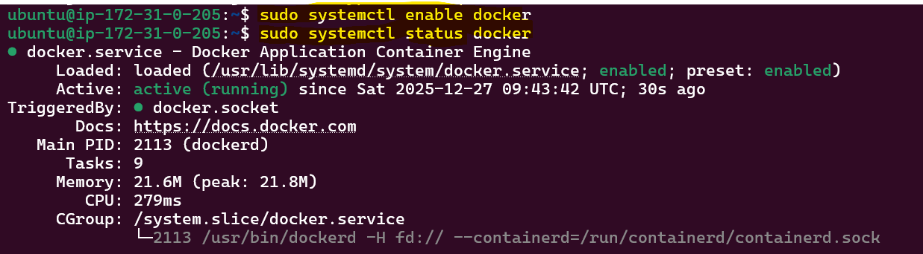
Build the Docker Image
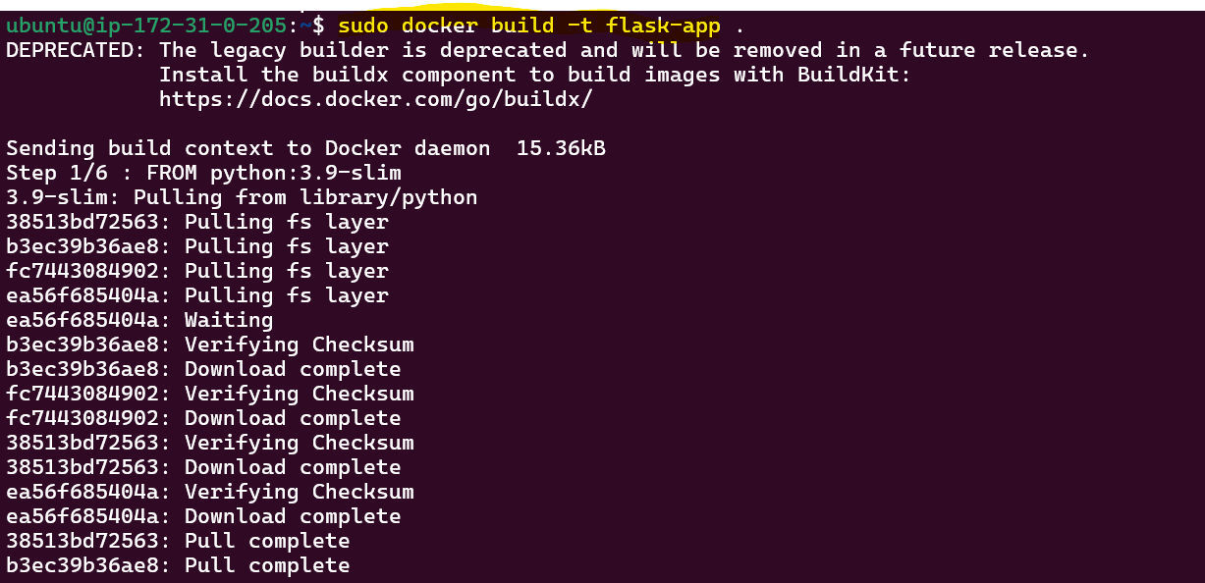
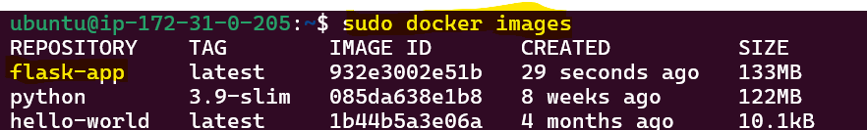
Run the Docker Container Locally and Image was created.
Run the container.
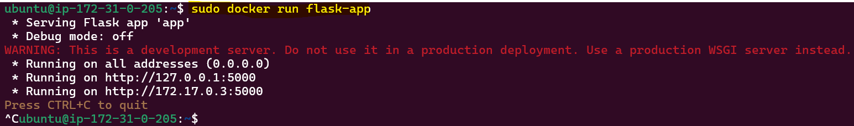
Basic details displayed in the website.
